Please tell me how you found this event/presentation
by drawing a circle around the correct answer:
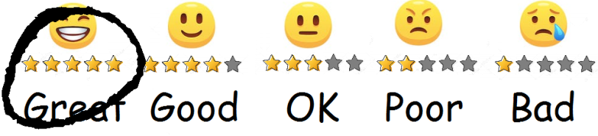
e.g.

Q.1 Overall, how would you rate  this event/presentation?  Please circle one option: | Q.2 Would you like to hear me speak at a future event?  Please circle one option:  YES NO

Q.3 How would you rate these descriptions of this event/presentation?
Please circle one option for each description:

Entertaining | Inspirational
Fun | Valuable
Engaging | Relevant
Different | Professional
Thought Provoking | Memorable

Optional Questions:

Q.4 What was the most useful thing(s)?

Q.5 What could I do to make this presentation better?

Other comments

